**A Report submitted**

**on the partial fulfillment of B.Tech Project**

**on**

**“Estimation Of Permeability From Wireline Data.”**

**Submitted by:**

Gaurav Bhatia (EPE19-022)

Harshit Singh (EPE19-028)

**Supervised by:**

Dr. Satish Kumar Sinha

Associate Professor (Petroleum Engineering Department)



Department of Petroleum Engineering & Geoengineering

**Rajiv Gandhi Institute Of Petroleum Technology, Jais**

ACKNOWLEDGEMENT

A B.Tech project is a golden opportunity for learning and self development. We

would like to express our sincere gratitude to **Prof. A.S.K. Sinha, Director,**

**RGIPT** for giving us the opportunity to undertake the B.Tech Project at the

Institute.

We would like to thank **Dr. Satish Kumar Sinha, Project Supervisor**, who in spite of

being extraordinarily busy with his duties took time out to hear, guide and keep us

on the correct path. We are blessed with the efforts and hard work put forward by

our mentor to guide us in best suited direction which helped us to go through new

concepts to inculcate in innovative minds. We are thankful to sir and express our

sincere gratitude for his indigenous guidance and constant encouragement

throughout the tenure of our project work. This project has provided new insights

and learning of Permeability Estimation using Machine Learning Models.

Sincerely,

Gaurav Bhatia (EPE19-022)

Harshit Singh (EPE19-028)

**Contents**

**Description**

**1. Objective**

**2. Introduction**

**3. Literature Review**

**4. Case Study Analysis**

**5. Introduction to Dataset**

**6. Data Pre-Processing & Analysis**

**7. Machine Learning Models**

**8. Introdution to RMSE**

**9. Error Calculation**

**10. Conclusion**

**11. Python Code Link**

**12. Future plannings**

**13. References-**

**Objectives**

Our objective is to determine the value of permeability from the wireline data of volve field using Machine Learning, and analyze the results in form of Root Mean Square Error. We aim to find the best fit model for the volve field dataset.

**INTRODUCTION**

**Permeability** is the property of a porous material that determines how easily fluid flows through that material, in response to an applied fluid pressure gradient. Reservoir permeability is a fundamental rock property which relate to its ability to flow when subjected to applied pressure gradients. This property has a significant impact on petroleum fields operations and reservoir management. In un-cored intervals and well, the reservoir description and characterization methods utilizing well logs represent a significant technical as well as economic advantage because well logs can provide a continuous record over the entire well. Hence, determination of appropriate value of Permeability from these logs are important for efficient interpretation purposes.

**Factors Affecting Permeability**

1) Porosity

2) Bedding

3)Pore Geometry

4) Stress Condition

5) Grain Size

6) Grain Shape

**METHODS OF DETERMINING PERMEABILITY**  
 *(EMPERICAL METHODS)*

**1) KOZENY- CARMAN EQUATION**

The Kozeny-Carman equation is often presented as permeability versus porosity, grain size, and tortuosity. When it is used to estimate permeability evolution versus porosity, some of these arguments (e.g., the grain size and tortuosity) are held constant.

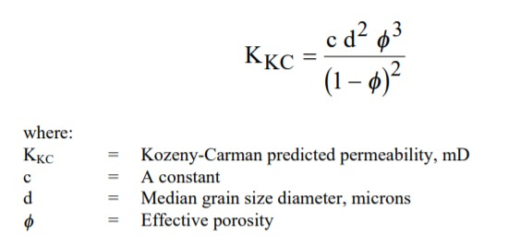

**2) RGPZ(Revil, Glover, Pezard, Zamora) EQUATION**

(RGPZ) permeability model have found increasing success for both conventional and tight, clastic and carbonate rocks. The equation is given as

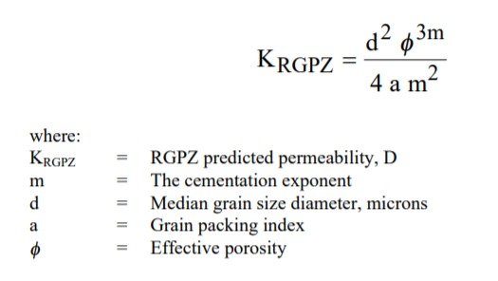

**LITERATURE REVIEW**

**ASSAM ARAKAN BASIN: CASE STUDY**

The Chandmari field of upper Assam-Arakan basin with the availability of only seven core samples and conventional logs such as density, porosity, resistivity and gamma ray data from few wells, was used for the estimation of permeability.

An attempt is made to estimate the permeability from well log and core data using Buckles’ method approach in sandstone reservoir of Eocene–Paleocene geologic age in the field under the assumption and geological support that reservoirs are clean sand having very less shale control and are homogenous reservoir with little or no heterogeneity.

Petrophysical evaluation from log data and core data are integrated for the analysis of the reservoir characteristics. The relationship between porosity and water saturation which is required to distinguish mobile from capillary bound water or irreducible water saturation is used to estimate the irreducible water saturation.

The estimated irreducible water saturation which is an essential parameter for permeability estimation is used for estimating the permeability in the field.

The estimated permeability in the reservoirs using Buckles’ method ranging from 1500 to 4554 mD is well matched with the permeability estimated from core sample.

The estimated permeability results suggest that the oil reservoir has the higher permeability than the gas reservoir.

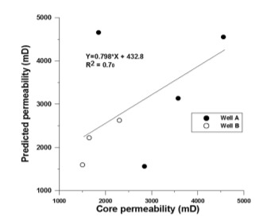

**Introduction To Dataset**

**Introduction to Volve Field:**

* Location: Volve field is located at 200 kilometers west of Stavanger at the southern end of the Norwegian sector.  
  The Production period for which the dataset is obtained:

**12 February 2008 - 17 September 2016**

* Production: At plateau, Volve produced some 56,000 barrels per day and delivered a total of 63 million barrels in the mentioned interval.

**Understanding the Volve Field Dataset:**

* This dataset contains PDF reports and LAS files of Geophysical Interpretations of well log data.
* The LAS file contains important information of - Depth, porosity, Bound Volume Water, Water Saturation, Permeability, VCARB, VSH.

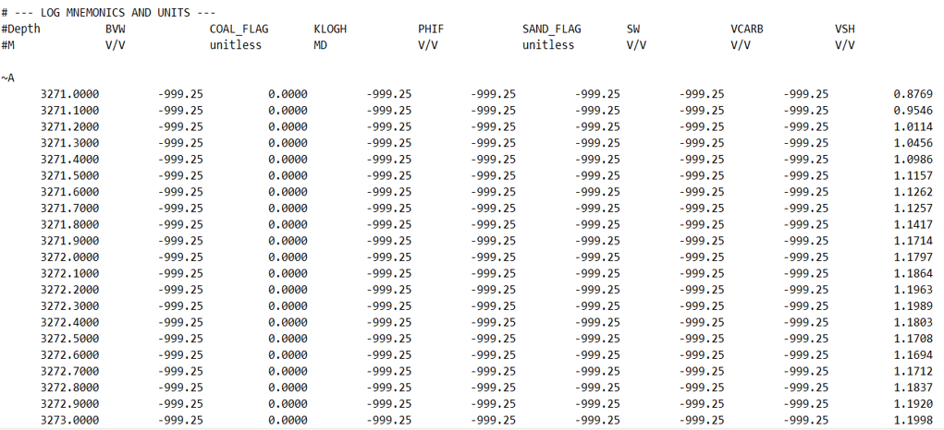

**Data Pre-Processing**

* Data from 9 well logs were interpreted through LAS files and the files were converted to excel for collective analysis.
* The missing and null values were filled with the mean of the column.
* As a result, data of **7 columns and 47731 rows** were obtained.
* The 7 columns include- **DEPTH, BVW, PHIF, SW, VCARB, VSH, KLOGH**.

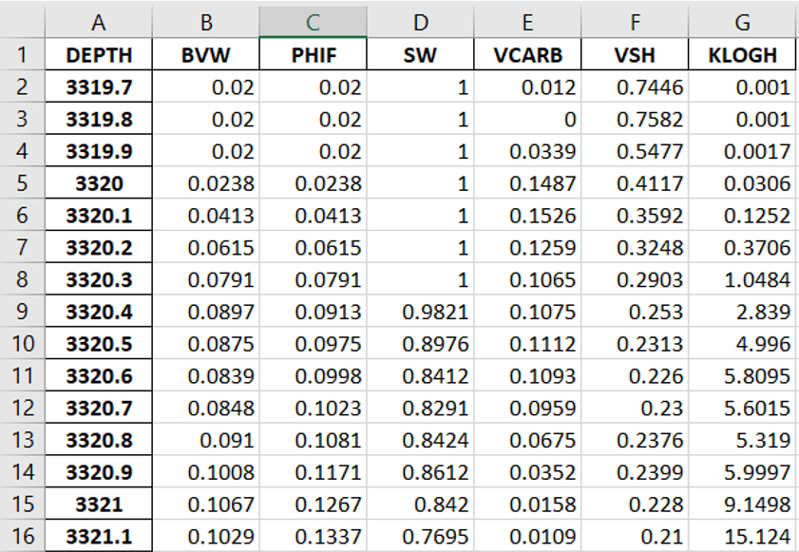

**DATA ANALYSIS**

* Each Column was analyzed in a manner such that it can prevent failure in machine learning modelling.
* VCARB column was removed as 43% entries were missing.
* Histograms were created using Python Programming Language to analyze the relationship between Permeability(KLOGH) and other variables.
* Outliers were removed for the better efficiency of the model.
* The analysis gave us the dependencies and density of points at different intervals.

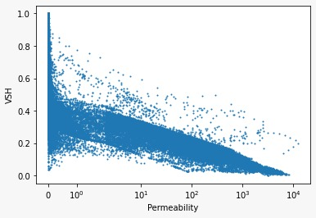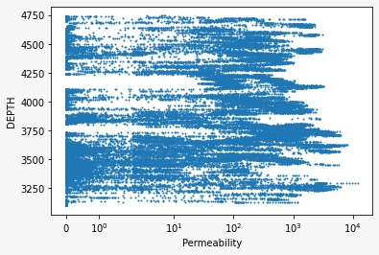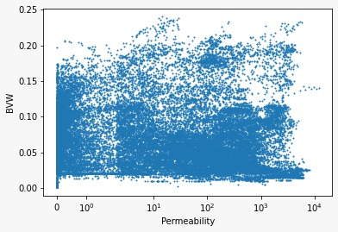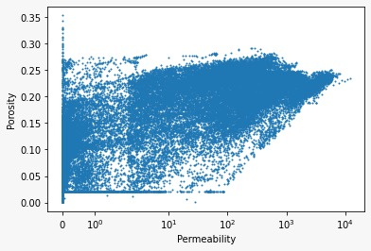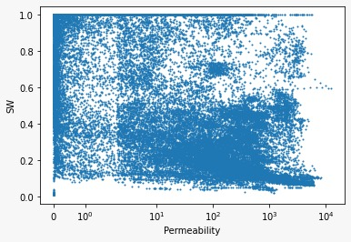

**MACHINE LEARNING MODELS**

**Machine Learning** is the field of study that gives computers the capability to learn.

4 Supervised Machine learning models are used in this project for the estimation of permeability from geophysical interpretation data of well logs. The Models used are namely:

* Multiple Linear Regression
* Decision Tree
* Random Forest
* Artificial Neural Networks

Note: All the models are trained using basic hyperparameters.

**ROOT MEAN SQUARE ERROR**

The root mean square error is calculated as:

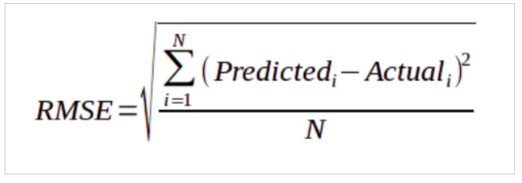

**MULTIPLE LINEAR REGRESSION**

Multiple Linear Regression attempts to model the relationship between two or more features and a response by fitting a linear equation to observed data. The steps to perform multiple linear Regression are almost similar to that of simple linear Regression. The Difference Lies in the evaluation. We can use it to find out which factor has the highest impact on the predicted output and now different variables relate to each other.

We use the simple multiple linear regression for prediction, with equation as;

**Y = β0 + β1X1 + β2X2 + β3X3 + .... + βpXp**

**Where Y = Permeability (output)**

**Xi= Input Variable (DEPTH, BVW, SW, PHIF, VSH)**

**BETA = Constant**

**Result of Multiple Linear Regression:**

We obtained a RMSE value of 588.37, which is not a good result.

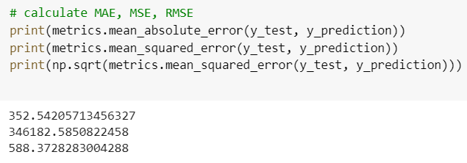

**DECISION TREE ALGORITHM**

**Decision Tree** is a decision-making tool that uses a flowchart-like tree structure to predict the continuous output results. We used this algorithm to decrease the linearity of the model. This algorithm categories the training of the model according to the constant parameters present in the dataset.

Result: The calculated RMSE value comes to be = 71.65, which is a good response. We are further trying to minimize the RMSE value using advanced algorithms.

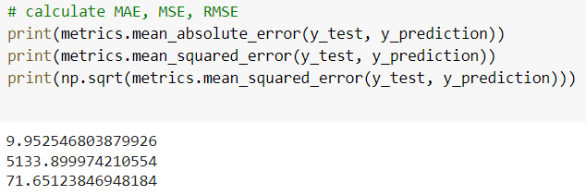

**Plot of: PREDICTED V/S TRUE PERMEABILITY**

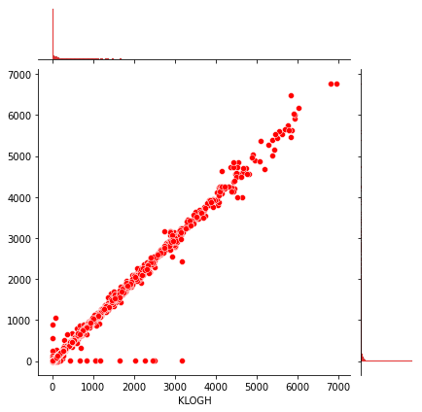

**X-Axis:** True Permeability

**Y-Axis:** Predicted Permeability

**RANDOM FOREST ALGORITHM**

* Every decision tree has high variance, but when we combine all of them together in parallel then the resultant variance is low as each decision tree gets perfectly trained on that particular sample data and hence the output doesn’t depend on one decision tree but multiple decision trees, hence the final output is the mean of all the outputs. This algorithm is RANDOM FOREST ALGORITHM.

**Working of Random Forest Algorithm**:

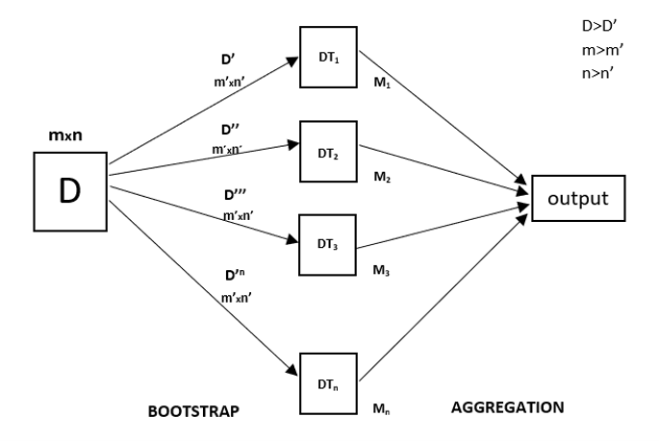

**Results of Random Forest Algorithm**: The RMSE obtained in this algorithm is 56.311

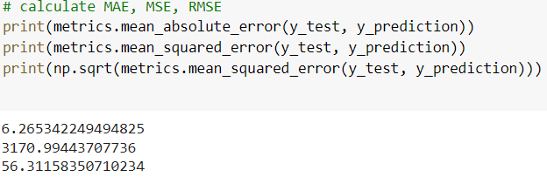

**Plot of: PREDICTED V/S TRUE PERMEABILITY**

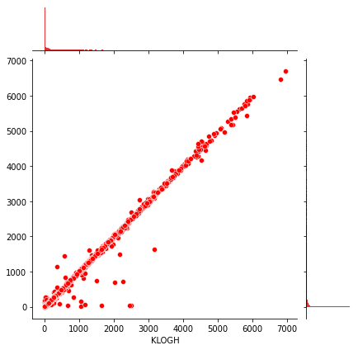

**ARTIFICIAL NEURAL NETWORK**

Forward Propagation: Let Y = WiIi = W1I1+W2I2+W3I3.....

    where Y is KLOGH, W is Weights, I is Variable

   Back Propagation

* The error is calculated i.e. the difference between the actual output and the expected output.
* Depending on the error,the weights are adjusted by multiplying the error with the input and again with the gradient of the Relu curve.

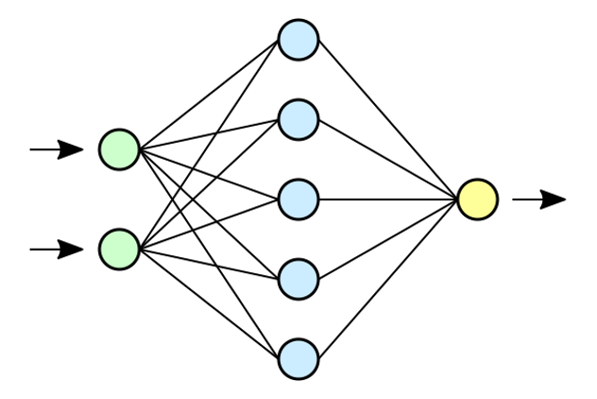 **Results of Artificial Neural Networks:**

The RMSE obtained in this algorithm is 49.38, which is a good response.

**CONCLUSION**

* Permeability estimation from conventional well logs in heterogeneous formation is a difficult and complex problem to solve by statistical methods
* The parametric methods like statistical regression require the assumption for the satisfaction of multi-normal behavior and linearity. Therefore, an artificial neural network (ANN) as a non-linear and non-parametric tool is becoming increasingly popular in well log analysis.
* Polynomial Neural Network (PNN) and Genetic Algorithm (GA), a new neural network approach to determine reservoir permeability from well logs is getting popular.
* Over-training or under-training is another pitfall. Over training of the network may result in the network memorizing the training set and lose its ability to generalize previously unseen data, while under-training of the network with low level of architecture cannot master the basic rules of the input patterns.

**Python Notebook Code Link**:

<https://colab.research.google.com/drive/1SBsUeq4LJFiz3ha9JRbly-1PCNoMpe0G?usp=sharing>

**FUTURE PLANNINGS**

* Working on Polynomial Neural Network approach to estimate permeability at different parameters.
* PNN is used to increase the non-linearity of the model for efficient training, that can prevent conditions like over-fitting.
* 8 conventional well logs are mainly considered for analysis: Neutron Log, Sonic Log, Gamma Ray Log, Caliper Log, Laterolog deep, Laterolog shallow, Density Log, and Spontaneous Potential Log.
* This approach is used in a well located at off-shore Korea, where the proposed PNN model performed the superior approximation and generalization capabilities compared with conventional ANN method

**References**

* SPE 100989- A New Neural Network Approach to Reservoir Permeability Estimation From Well Logs
* Porosity and permeability prediction from wireline logs using artificial neural networks: a North Sea case study
* Permeability prediction from wireline logging and core data: a case study from Assam‑Arakan basin
* Microsoft Azure: Volve Field Dataset - https://www.equinor.com/en/what-we-do/norwegian-continental-shelf-platforms/volve.html